% Exercise 1

function LAB05ex1

m = 1;

k = 4;

omega0=sqrt(k/m);

y0 = 0.1; v0 = 0;

[t,Y]=ode45(@f,[0,10],[y0,v0],[],omega0);

Y = Y(:,1); v = Y(:,2);

figure(1); plot(t,y,'b+-',t,v,'ro-');

grid on;

%------------------------------------------------------

function dYdt = f(t,Y,omega0)

y = Y(1); v= Y(2);

dYdt = [v; -omega0^2\*y];

This plot displays amplitude vs. time for a free-running spring. Since no energy was lost in this system, the amplitude’s maximum and minimum were maintained at constant values.

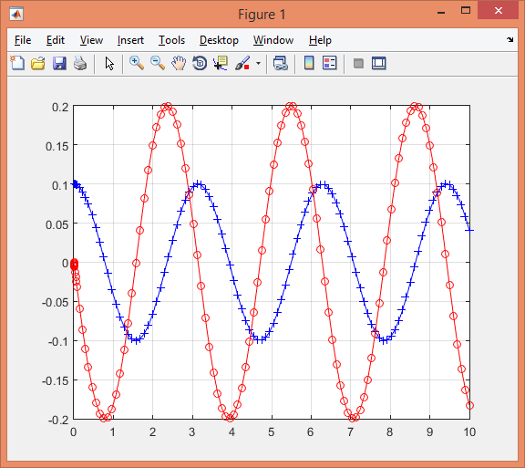

% part(a) The blue curve represents y = y(t) because of the initial condition y(0).

% part(b) The period is $π$.

$T=\frac{2π}{ω_{0}}=\frac{2π}{2}=π$

% part(c) Assuming the system is running in vacuum. In this case the mass will never come to rest because there is no damping factor in the system.

% part(d) From the graph above, it can be observed that the amplitude of oscillation is 0.1.

% part(e) The maximum speed attained equals the amplitude of the red curve which is 0.2 at t values of $π/4$, $3π/4$, $5π/4$, etc...

% part(f) When k is fixed and m increases, the period T increases. When the m is fixed, and k is increased, the period T decreases, as shown in the equation below.

$$T=\frac{2π}{w_{o}}=2π\sqrt{\frac{m}{k}}$$

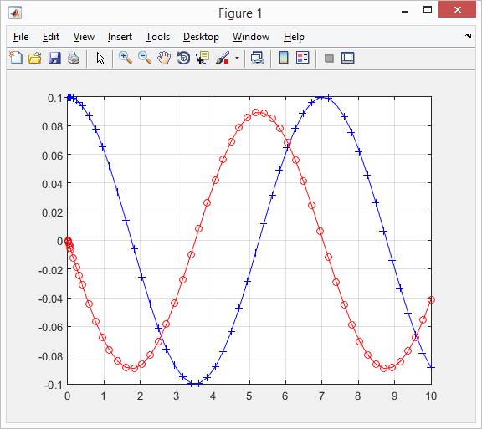

Exercise 1, part f: m = 5, k = 4

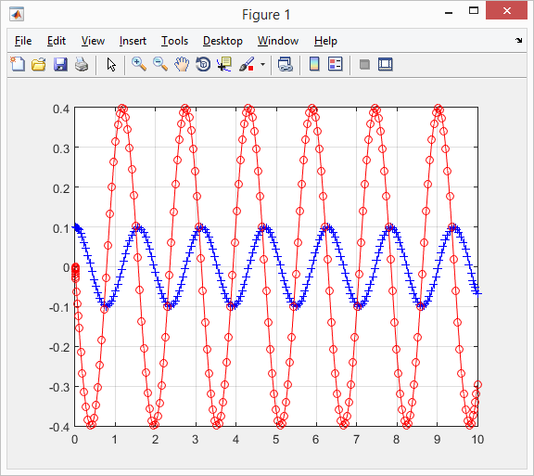

Exercise 1, part f: m = 1, k = 16

%Exercise 2

function LAB05ex1

m = 1;

k = 4;

c = 1;

omega0 = sqrt(k/m); p = c/(2\*m);

y0 = 0.1; v0 = 0;

[t,Y]=ode45(@f,[0,10],[y0,v0],[],omega0,p);

y=Y(:,1); v=Y(:,2);

figure(1); plot(t,y,'b+-',t,v,'ro-');

grid on

E=(1/2)\*m\*v.^2+(1/2)\*k\*y.^2;

figure(2)

plot(t,E)

ylim([0,0.04])

%------------------------------------------------------

function dYdt= f(t,Y,omega0,p)

y = Y(1); v= Y(2);

dYdt= [v; -omega0^2\*y];

% part(a) When the limits on y changed, a straight line occurs.

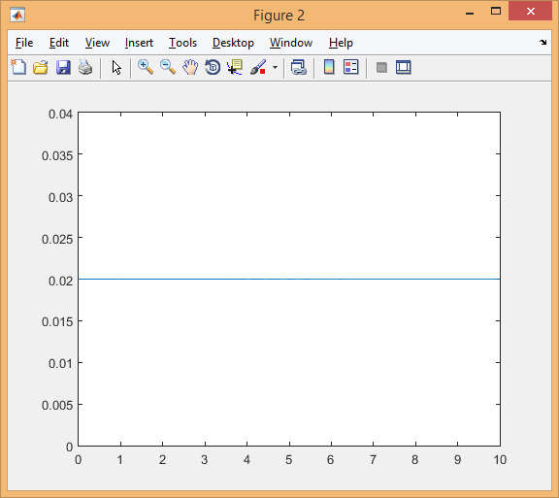

The above plot shows energy vs. time for an undamped spring.

The slope of the line is zero, meaning $\frac{dE}{dt}$ = 0.

The energy remains at the constant value of 0.02.

% part(b)

$$E=\frac{1}{2}mv^{2}+\frac{1}{2}ky^{2}$$

$$\frac{∂E}{∂t}=mvv^{'}+kyy^{'}$$

$$From ODE: v=y^{'}v^{'}=y"=-ω_{0}^{2}y$$

$$\frac{∂E}{∂t}=my^{'}\left(-ω_{0}^{2}y\right)+kyy'$$

$$=my^{'}\left(-\frac{k}{m}y\right)+kyy'$$

$$=-kyy^{'}+kyy^{'}=0$$

% part(c)

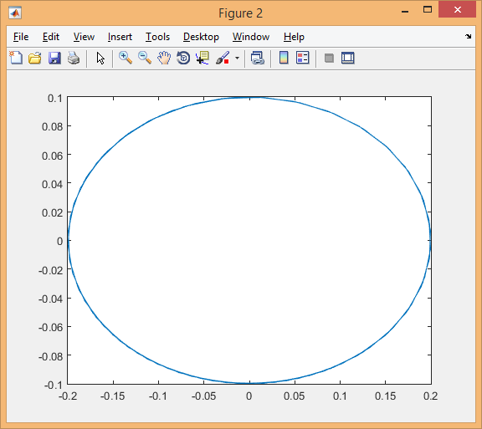

The plot is an ellipse; since the plot never goes through or even approaches the origin, the mass never comes to rest. Velocity and position can never be 0 simultaneously.

%Exercise 3

function LAB05ex1

m = 1;

k = 4;

c = 1;

omega0 = sqrt(k/m); p = c/(2\*m);

y0 = 0.1; v0 = 0;

[t,Y]=ode45(@f,[0,10],[y0,v0],[],omega0,p);

Y = Y(:,1); v = Y(:,2);

figure(1); plot(t,y,'b+-',t,v,'ro-');

grid on

for i = 1:length(y)

m(i) = max(abs(y(i:end)));

end

i = find(m<0.01); i = i(1);

disp(['|y|<0.01 for t>t1 with ' num2str(t(i-1)) '<t1<' num2str(t(i))])

vmax = max(abs(v));

i=find(v<=-vmax);

disp(['maximum velocity is v = ' num2str(vmax) 'attained at t =' num2str(t(i))])

figure(2);

plot(y,v)

grid on

xlabel('y')

ylabel('v')

%----------------------------------------------------------------------

function dYdt= f(t,Y,omega0,p)

y = Y(1); v= Y(2);

dYdt = [v; -2\*p\*v-(omega0^2)\*y];

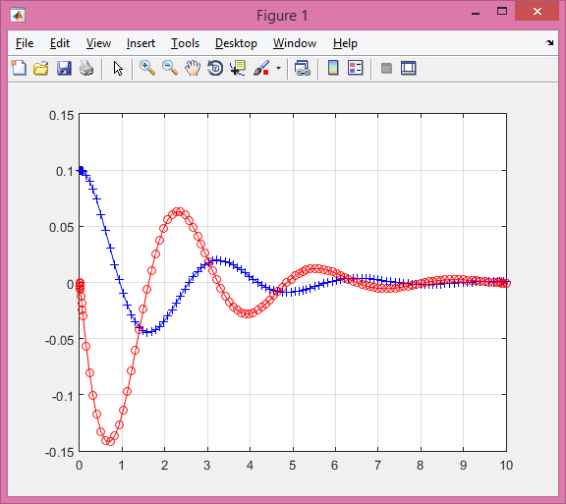

The above plot shows the amplitude vs. time for a damping spring. The curve does not maintain a constant max and min amplitude because of energy is loss in the system.

>> LAB05ex1c

|y|<0.01 for t>t1 with 3.7807<t1<3.8711

maximum velocity is v = 0.14197 attained at t = 0.71477

% part(a) Function output:

|y|<0.01 for t>t1 with 3.7807<t1<3.8711

The time t1 where the mass-spring system satisfies |y|<0.01 is from time 3.7807<t1<3.8711. This was found by adding the response of MatLab’s *find()* function.

% part(b) Function output:

maximum velocity is v = 0.14197 attained at t = 0.71477

Instead of using the magnify option and finding an approximate amplitude, the MatLab’s *find()* function used to find the time t1 in part (a) was reused to find the maximum velocity. At time 0.71477, a maximum velocity of 0.14197 was found.

% part(c)

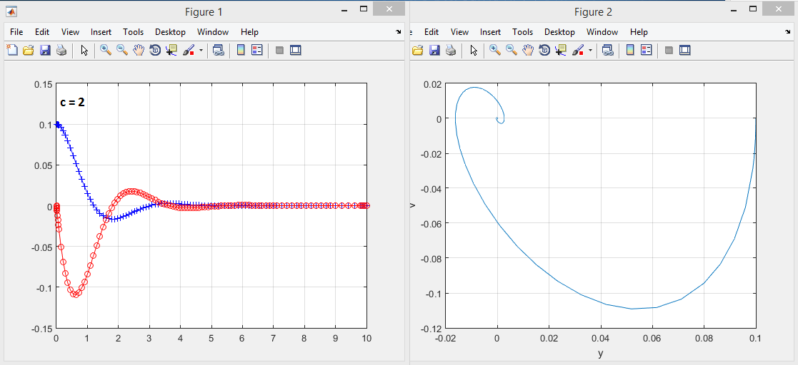

c = 2

|y|<0.01 for t>t1 with 2.3296<t1<2.4207

maximum velocity is v = 0.1091attained at t =0.63078

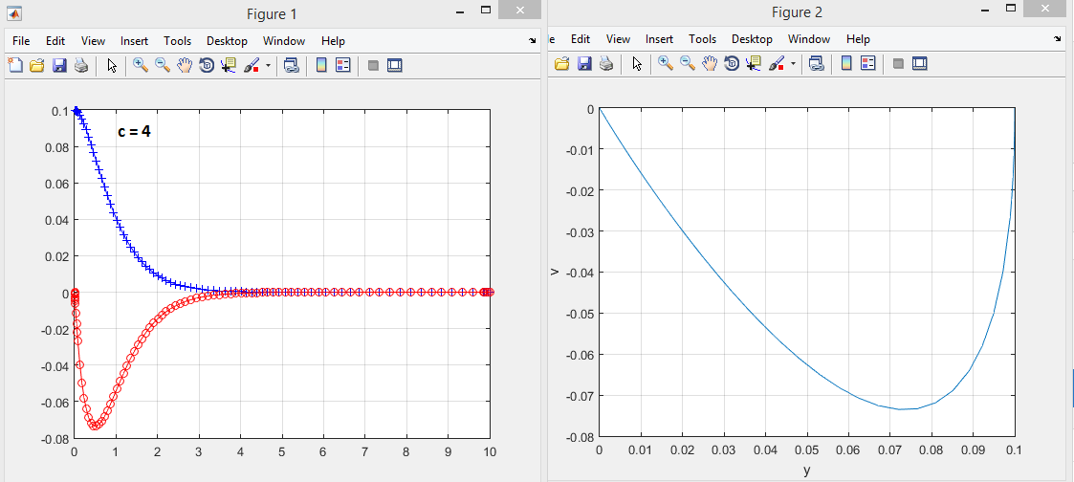

c = 4

|y|<0.01 for t>t1 with 1.9054<t1<2.0075

maximum velocity is v = 0.073511attained at t =0.52069

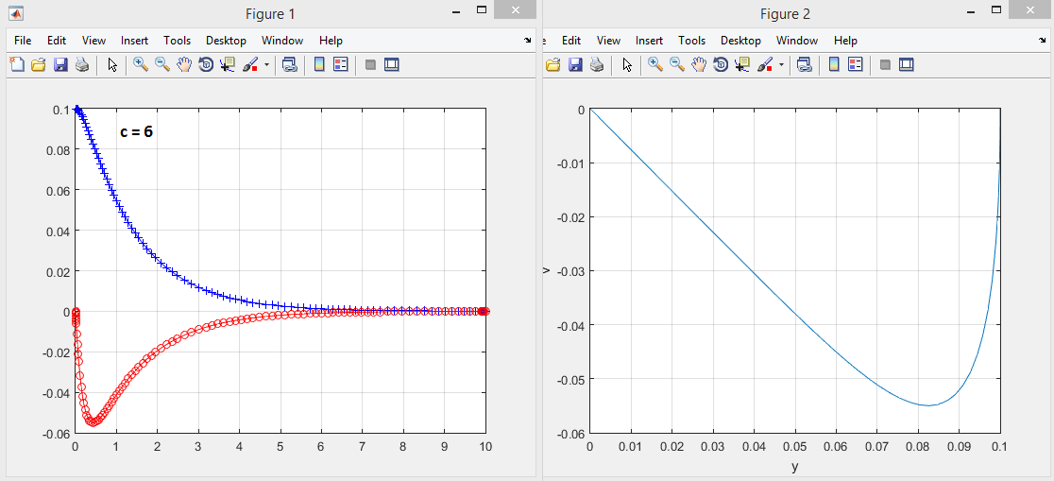

c = 6

|y|<0.01 for t>t1 with 3.1817<t1<3.3253

maximum velocity is v = 0.054992attained at t =0.42853

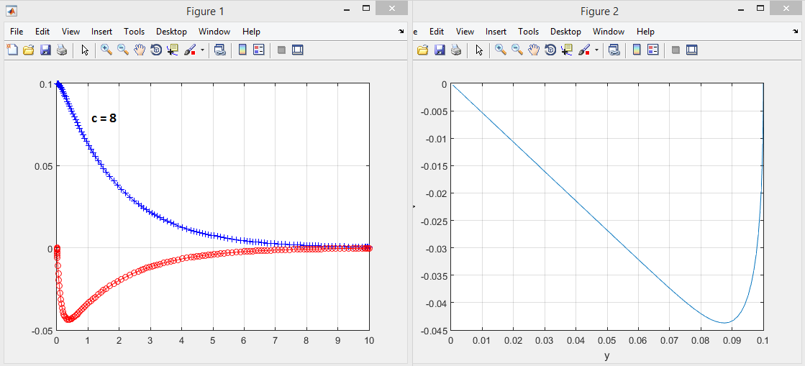

c = 8

|y|<0.01 for t>t1 with 4.392<t1<4.4823

maximum velocity is v = 0.04371attained at t =0.37485

Observation: The larger the c value, the less the spring dampens. Also, the value of c alters the time it takes the system to reach equilibrium and come to rest.

The path of the position vs. velocity plot becomes less curved when c increases, thus shortening the curve length. This implies that the system travels a smaller total distance before coming to rest.

% part(d)

No oscillation occurs if and only if the characteristic equation has no complex roots.

$$mu^{''}+cu^{'}+ku=F(t)$$

$$mu^{''}+cu^{'}+ku=u$$

$$mr^{2}+cr+k$$

$-c±\sqrt{c^{2}-4mk}$ (Quadratic equation)

$$*discriminant must be≥0. Smallest critical value when discriminant=0$$

$$c^{2}-4mk=0$$

$$c≥\sqrt{4mk}$$

%Exercise 4

function LAB05ex1

m = 1;

k = 4;

c = 1;

omega0 = sqrt(k/m); p = c/(2\*m);

y0 = 0.1; v0 = 0;

[t,Y]=ode45(@f,[0,10],[y0,v0],[],omega0,p);

y = Y(:,1); v = Y(:,2);

figure(1); plot(t,y,'b+-',t,v,'ro-');

grid on

figure(2)

plot(y,v)

grid on

xlabel('y')

ylabel('v')

E=(1/2)\*m\*v.^2+(1/2)\*k\*y.^2; % total energy equation

figure(3)

plot(t,E) % plot energy vs. time

%------------------------------------------------------

function dYdt= f(t,Y,omega0,p) % function dYdt

y = Y(1); v= Y(2); % assign values of y and v

dYdt = [v; -2\*p\*v-(omega0^2)\*y ]; % fill-in dv/dt

% part(a) Energy is no longer conserved in this system because there is now a damping constant in the system.

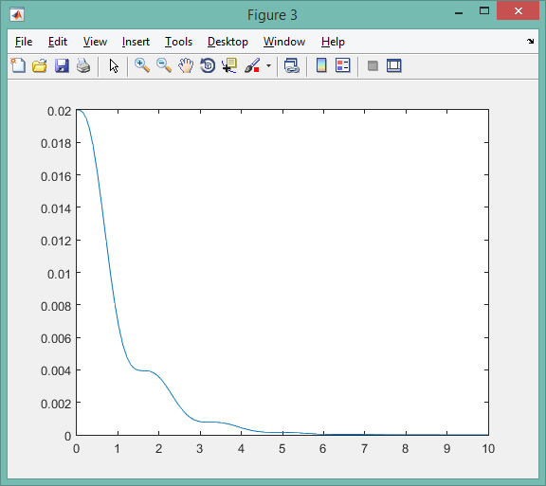

The above graph shows energy vs. time for the damped spring. Energy approaches 0 over time.

% part(b)

$v^{'}=y^{''}=-\frac{c}{my^{'}}-\frac{k}{m}y$

$$\frac{∂E}{∂t}=my^{'}\left(-\frac{c}{my^{'}}-\frac{k}{m}y\right)+kyy'$$

$$=-c{\left(y^{'}\right)}^{2}-kyy^{'}+kyy'$$

$=-c{\left(y^{'}\right)}^{2}$ $∴ \frac{∂E}{∂t}<0 for c>0 and \frac{∂E}{∂t}>0 for c<0$

$${*\left(y^{'}\right)}^{2} is always greater than or equal to zero$$

% part(c)

The energy is not conserved in this system because there is now damping present. This causes the energy to decrease over time, which causes the system to eventually come to rest.

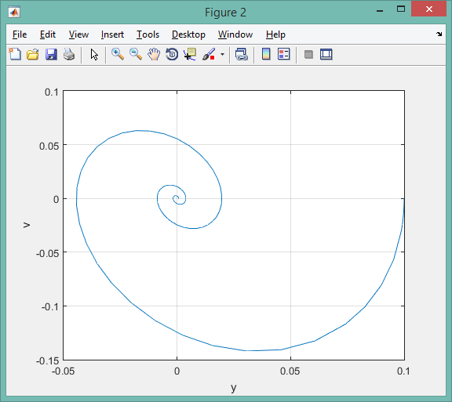

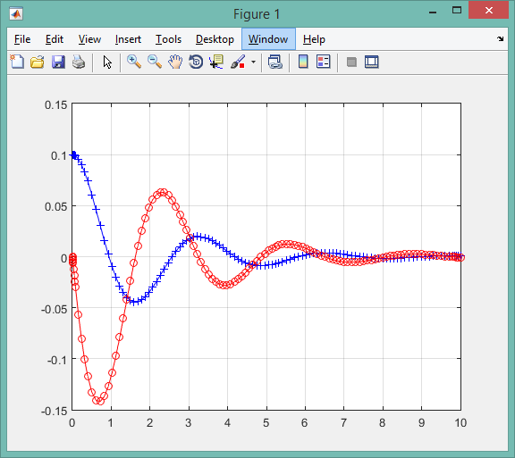

Damped spring – Oscillation eventually dies out.